PROMISE & PRACTICE · GROWTH & CONFLICT · SOURCE ANALYSIS
The Black Hawk War
The Sauk and the Meskwaki
Name: ______________________________ Period: _____ Date: ________________
WHAT I CAN DO TODAY I can read primary sources about The Black Hawk War, weigh who made each one and why, and use evidence to answer historical questions.
Directions. Read the lesson on the Black Hawk War one section at a time. For each section, answer in your own words: retell it in 2–3 sentences, name the single key idea, and note one word you figured out or one question you still have
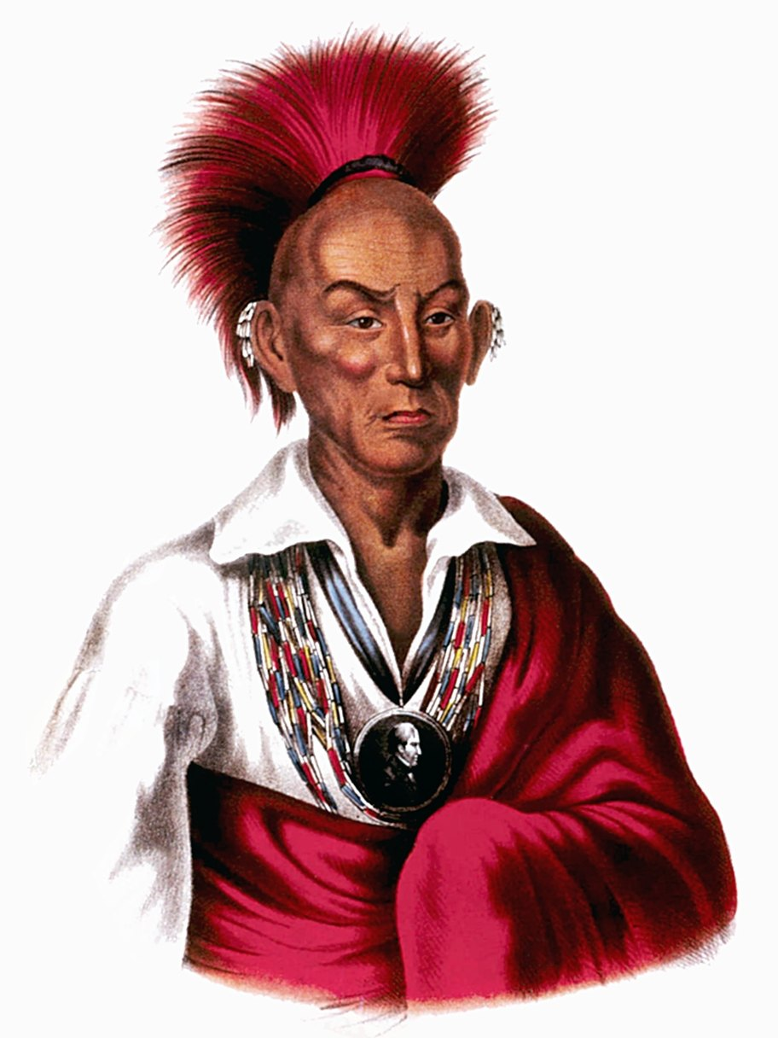
Black Hawk — lithograph after Charles Bird King, from McKenney & Hall, History of the Indian Tribes of North America (public domain, via Wikimedia Commons).

THE SOURCES
NOW READ THE REAL THING — Primary source: Black Hawk’s surrender speech, 1832
“I am a man and you are another. … We did not expect to conquer the whites; they had too many houses and too many men. I took up the hatchet, for my part, to revenge injuries which my people could no longer endure. … He has done nothing for which an Indian ought to be ashamed. He has fought for his countrymen, against white men who came, year after year, to cheat them and take away their lands.”
Black Hawk, at his surrender, 1832 — recorded in Frank E. Stevens, The Black Hawk War (1903).

YOUR WORK
RETELL THIS CHUNK IN 2–3 SENTENCES, AS IF EXPLAINING IT TO A FRIEND.
Retell this chunk in 2–3 sentences, as if explaining it to a friend.
____________________________________________________________________________________________
____________________________________________________________________________________________
____________________________________________________________________________________________
WHAT IS THE SINGLE MOST IMPORTANT IDEA IN THIS CHUNK? ONE SENTENCE.
What is the single most important idea in this chunk? One sentence.
____________________________________________________________________________________________
____________________________________________________________________________________________
____________________________________________________________________________________________
NAME ONE WORD YOU HAD TO FIGURE OUT (AND WHAT IT MEANS), OR ONE QUESTION YOU STILL HAVE.
Name one word you had to figure out (and what it means), OR one question you still have.
____________________________________________________________________________________________
____________________________________________________________________________________________
____________________________________________________________________________________________
RETELL THIS CHUNK IN 2–3 SENTENCES, AS IF EXPLAINING IT TO A FRIEND.
Retell this chunk in 2–3 sentences, as if explaining it to a friend.
____________________________________________________________________________________________
____________________________________________________________________________________________
____________________________________________________________________________________________
WHAT IS THE SINGLE MOST IMPORTANT IDEA IN THIS CHUNK? ONE SENTENCE.
What is the single most important idea in this chunk? One sentence.
____________________________________________________________________________________________
____________________________________________________________________________________________
____________________________________________________________________________________________
NAME ONE WORD YOU HAD TO FIGURE OUT (AND WHAT IT MEANS), OR ONE QUESTION YOU STILL HAVE.
Name one word you had to figure out (and what it means), OR one question you still have.
____________________________________________________________________________________________
____________________________________________________________________________________________
____________________________________________________________________________________________
RETELL THIS CHUNK IN 2–3 SENTENCES, AS IF EXPLAINING IT TO A FRIEND.
Retell this chunk in 2–3 sentences, as if explaining it to a friend.
____________________________________________________________________________________________
____________________________________________________________________________________________
____________________________________________________________________________________________
WHAT IS THE SINGLE MOST IMPORTANT IDEA IN THIS CHUNK? ONE SENTENCE.
What is the single most important idea in this chunk? One sentence.
____________________________________________________________________________________________
____________________________________________________________________________________________
____________________________________________________________________________________________
NAME ONE WORD YOU HAD TO FIGURE OUT (AND WHAT IT MEANS), OR ONE QUESTION YOU STILL HAVE.
Name one word you had to figure out (and what it means), OR one question you still have.
____________________________________________________________________________________________
____________________________________________________________________________________________
____________________________________________________________________________________________
RETELL THIS CHUNK IN 2–3 SENTENCES, AS IF EXPLAINING IT TO A FRIEND.
Retell this chunk in 2–3 sentences, as if explaining it to a friend.
____________________________________________________________________________________________
____________________________________________________________________________________________
____________________________________________________________________________________________
WHAT IS THE SINGLE MOST IMPORTANT IDEA IN THIS CHUNK? ONE SENTENCE.
What is the single most important idea in this chunk? One sentence.
____________________________________________________________________________________________
____________________________________________________________________________________________
____________________________________________________________________________________________
NAME ONE WORD YOU HAD TO FIGURE OUT (AND WHAT IT MEANS), OR ONE QUESTION YOU STILL HAVE.
Name one word you had to figure out (and what it means), OR one question you still have.
____________________________________________________________________________________________
____________________________________________________________________________________________
____________________________________________________________________________________________
RETELL THIS CHUNK IN 2–3 SENTENCES, AS IF EXPLAINING IT TO A FRIEND.
Retell this chunk in 2–3 sentences, as if explaining it to a friend.
____________________________________________________________________________________________
____________________________________________________________________________________________
____________________________________________________________________________________________
WHAT IS THE SINGLE MOST IMPORTANT IDEA IN THIS CHUNK? ONE SENTENCE.
What is the single most important idea in this chunk? One sentence.
____________________________________________________________________________________________
____________________________________________________________________________________________
____________________________________________________________________________________________
NAME ONE WORD YOU HAD TO FIGURE OUT (AND WHAT IT MEANS), OR ONE QUESTION YOU STILL HAVE.
Name one word you had to figure out (and what it means), OR one question you still have.
____________________________________________________________________________________________
____________________________________________________________________________________________
____________________________________________________________________________________________
RETELL THIS CHUNK IN 2–3 SENTENCES, AS IF EXPLAINING IT TO A FRIEND.
Retell this chunk in 2–3 sentences, as if explaining it to a friend.
____________________________________________________________________________________________
____________________________________________________________________________________________
____________________________________________________________________________________________
WHAT IS THE SINGLE MOST IMPORTANT IDEA IN THIS CHUNK? ONE SENTENCE.
What is the single most important idea in this chunk? One sentence.
____________________________________________________________________________________________
____________________________________________________________________________________________
____________________________________________________________________________________________
NAME ONE WORD YOU HAD TO FIGURE OUT (AND WHAT IT MEANS), OR ONE QUESTION YOU STILL HAVE.
Name one word you had to figure out (and what it means), OR one question you still have.
____________________________________________________________________________________________
____________________________________________________________________________________________
____________________________________________________________________________________________
RETELL THIS CHUNK IN 2–3 SENTENCES, AS IF EXPLAINING IT TO A FRIEND.
Retell this chunk in 2–3 sentences, as if explaining it to a friend.
____________________________________________________________________________________________
____________________________________________________________________________________________
____________________________________________________________________________________________
WHAT IS THE SINGLE MOST IMPORTANT IDEA IN THIS CHUNK? ONE SENTENCE.
What is the single most important idea in this chunk? One sentence.
____________________________________________________________________________________________
____________________________________________________________________________________________
____________________________________________________________________________________________
NAME ONE WORD YOU HAD TO FIGURE OUT (AND WHAT IT MEANS), OR ONE QUESTION YOU STILL HAVE.
Name one word you had to figure out (and what it means), OR one question you still have.
____________________________________________________________________________________________
____________________________________________________________________________________________
____________________________________________________________________________________________
WHO IS SPEAKING, WHEN, AND WHY? HOW MIGHT THAT SHAPE WHAT HE CHOOSES TO SAY?
Who is speaking, when, and why? How might that shape what he chooses to say?
____________________________________________________________________________________________
____________________________________________________________________________________________
____________________________________________________________________________________________
WHAT REASON DOES BLACK HAWK GIVE FOR GOING TO WAR — AND HOW DOES HEARING IT IN HIS OWN WORDS CHANGE THE STORY YOU READ IN THE CHUNKS?
What reason does Black Hawk give for going to war — and how does hearing it in his own words change the story you read in the chunks?
____________________________________________________________________________________________
____________________________________________________________________________________________
____________________________________________________________________________________________
HOW DID THE BLACK HAWK WAR CHANGE ILLINOIS? WRITE 4–6 SENTENCES, USING DETAILS FROM AT LEAST THREE CHUNKS.
How did the Black Hawk War change Illinois? Write 4–6 sentences, using details from at least THREE chunks.
____________________________________________________________________________________________
____________________________________________________________________________________________
____________________________________________________________________________________________
WAS THE BLACK HAWK WAR REALLY A “WAR” — OR WAS IT THE REMOVAL OF A PEOPLE WHO WERE ONLY TRYING TO GO HOME? EXPLAIN WHAT YOU THINK, AND WHY.
Was the Black Hawk War really a “war” — or was it the removal of a people who were only trying to go home? Explain what you think, and why.
____________________________________________________________________________________________
____________________________________________________________________________________________
____________________________________________________________________________________________
Promise & Practice · ShadowDog Digital Studios · Unit 2

TEACHER ANSWER KEY — The Black Hawk War

Retell this chunk in 2–3 sentences, as if explaining it to a friend.: Open response.
Look for a response along the lines of: “Retell this chunk in 2–3 sentences, as if explaining it to a friend.”
What is the single most important idea in this chunk? One sentence.: Open response.
Look for a response along the lines of: “What is the single most important idea in this chunk? One sentence.”
Name one word you had to figure out (and what it means), OR one question you still have.: Open response.
Look for a response along the lines of: “Name one word you had to figure out (and what it means), OR one question you still have.”
Retell this chunk in 2–3 sentences, as if explaining it to a friend.: Open response.
Look for a response along the lines of: “Retell this chunk in 2–3 sentences, as if explaining it to a friend.”
What is the single most important idea in this chunk? One sentence.: Open response.
Look for a response along the lines of: “What is the single most important idea in this chunk? One sentence.”
Name one word you had to figure out (and what it means), OR one question you still have.: Open response.
Look for a response along the lines of: “Name one word you had to figure out (and what it means), OR one question you still have.”
Retell this chunk in 2–3 sentences, as if explaining it to a friend.: Open response.
Look for a response along the lines of: “Retell this chunk in 2–3 sentences, as if explaining it to a friend.”
What is the single most important idea in this chunk? One sentence.: Open response.
Look for a response along the lines of: “What is the single most important idea in this chunk? One sentence.”
Name one word you had to figure out (and what it means), OR one question you still have.: Open response.
Look for a response along the lines of: “Name one word you had to figure out (and what it means), OR one question you still have.”
Retell this chunk in 2–3 sentences, as if explaining it to a friend.: Open response.
Look for a response along the lines of: “Retell this chunk in 2–3 sentences, as if explaining it to a friend.”
What is the single most important idea in this chunk? One sentence.: Open response.
Look for a response along the lines of: “What is the single most important idea in this chunk? One sentence.”
Name one word you had to figure out (and what it means), OR one question you still have.: Open response.
Look for a response along the lines of: “Name one word you had to figure out (and what it means), OR one question you still have.”
Retell this chunk in 2–3 sentences, as if explaining it to a friend.: Open response.
Look for a response along the lines of: “Retell this chunk in 2–3 sentences, as if explaining it to a friend.”
What is the single most important idea in this chunk? One sentence.: Open response.
Look for a response along the lines of: “What is the single most important idea in this chunk? One sentence.”
Name one word you had to figure out (and what it means), OR one question you still have.: Open response.
Look for a response along the lines of: “Name one word you had to figure out (and what it means), OR one question you still have.”
Retell this chunk in 2–3 sentences, as if explaining it to a friend.: Open response.
Look for a response along the lines of: “Retell this chunk in 2–3 sentences, as if explaining it to a friend.”
What is the single most important idea in this chunk? One sentence.: Open response.
Look for a response along the lines of: “What is the single most important idea in this chunk? One sentence.”
Name one word you had to figure out (and what it means), OR one question you still have.: Open response.
Look for a response along the lines of: “Name one word you had to figure out (and what it means), OR one question you still have.”
Retell this chunk in 2–3 sentences, as if explaining it to a friend.: Open response.
Look for a response along the lines of: “Retell this chunk in 2–3 sentences, as if explaining it to a friend.”
What is the single most important idea in this chunk? One sentence.: Open response.
Look for a response along the lines of: “What is the single most important idea in this chunk? One sentence.”
Name one word you had to figure out (and what it means), OR one question you still have.: Open response.
Look for a response along the lines of: “Name one word you had to figure out (and what it means), OR one question you still have.”
Who is speaking, when, and why? How might that shape what he chooses to say?: Open response.
Look for a response along the lines of: “Who is speaking, when, and why? How might that shape what he chooses to say?”
What reason does Black Hawk give for going to war — and how does hearing it in his own words change the story you read in the chunks?: Open response.
Look for a response along the lines of: “What reason does Black Hawk give for going to war — and how does hearing it in his own words change the story you read in the chunks?”
How did the Black Hawk War change Illinois? Write 4–6 sentences, using details from at least THREE chunks.: Open response.
Look for a response along the lines of: “How did the Black Hawk War change Illinois? Write 4–6 sentences, using details from at least THREE chunks.”
Was the Black Hawk War really a “war” — or was it the removal of a people who were only trying to go home? Explain what you think, and why.: Open response.
Look for a response along the lines of: “Was the Black Hawk War really a “war” — or was it the removal of a people who were only trying to go home? Explain what you think, and why.”

